IBP2012-IVIS-004 Generating the F2 Nursery

Objectives:

At the end of this chapter, the user should be able to:

A. Make the F2 Nursery List
- Import selection information into an existing Nursery
- Advance a nursery to produce a harvest list
B. Make the F2 Nursery Book
- Use the wizard steps to generate the F2 nursery book
- Export the F2 nursery book for data collection.

A. Make the F2 Nursery List
Tutorial Steps:

- Open the exported file – UCR2010F1.xls from the previous tutorial and add Notes and PLANTS Selected as follows: For the first ten entries add “Failed” in the NOTES and 0 in the PLANTS SELECTED columns to indicate crosses which failed and for which no selection will be made. Enter the same values for the last 14 crosses – UCE2010091 to UCR2010104. Fill the rest of the rows with “Succeeded” and “1” to indicate that seeds will be bulked from F1 plants for those crosses. Save the changes. (File UCR2010F1_Data.xls in directory \ICIS5\Document\Training\IVIS has this data if you want to avoid typing).

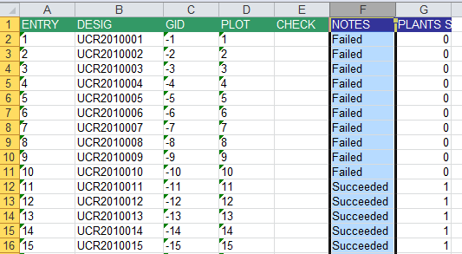
…
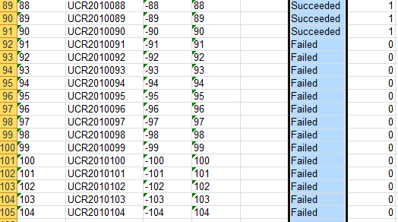

- Run the Breeding manager from the IB Workbench. Open the tree for the Study UCR2010 Nurseries and Highlight the UCR201F1 nursery. Right click on this nursery and select Open.

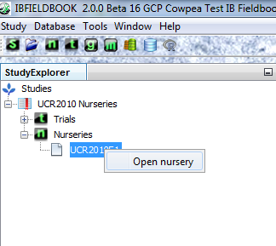
- Once the Nursery is open, click on the Measurements tab and then click Import. Select "Excel File”

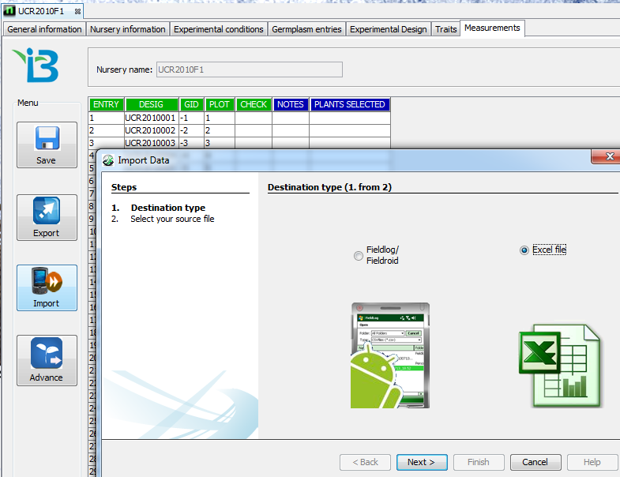

- Click Next, browse to the directory where the Nursery Book, UCR2010F1.xls is stored and open it.
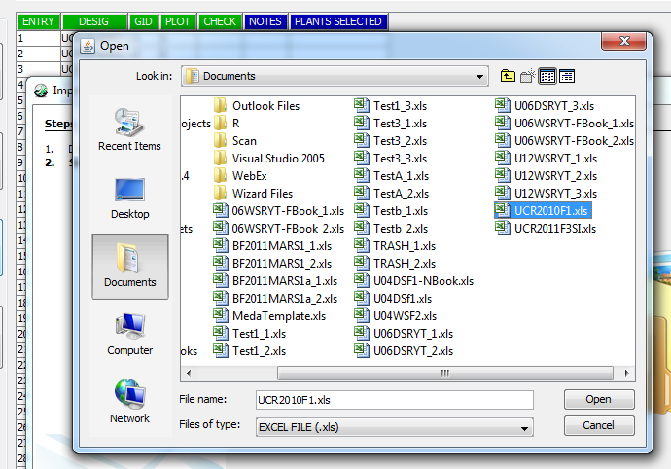

- The Data will be loaded into the Measurements Tab. Click Save to store the data. Then Click Advance to form the list for the F2 seeds.

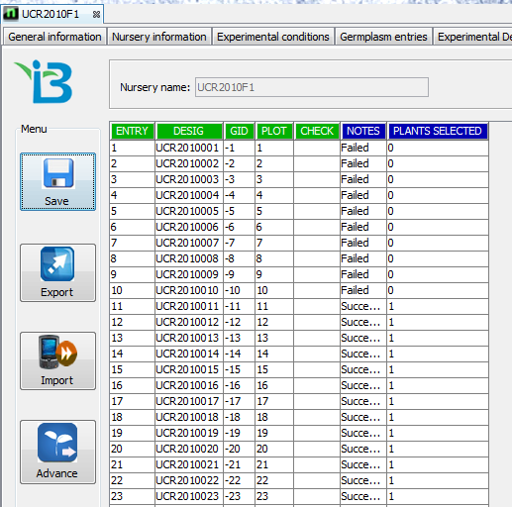

- The Advance Nursery Wizard opens. Check “Yes” to the question “Is the breeding method the same for each advanced line?” and select “Random Bulk SF from the pull down list of methods. Click “No” to the question “Are the same number of lines selected from each plot?” Select a harvest Date eg 20100723, select a naming convention for OTHER CROPS, add a name suffix “B” to indicate Bulk, and select the harvest location – UCR. Click “Finish”

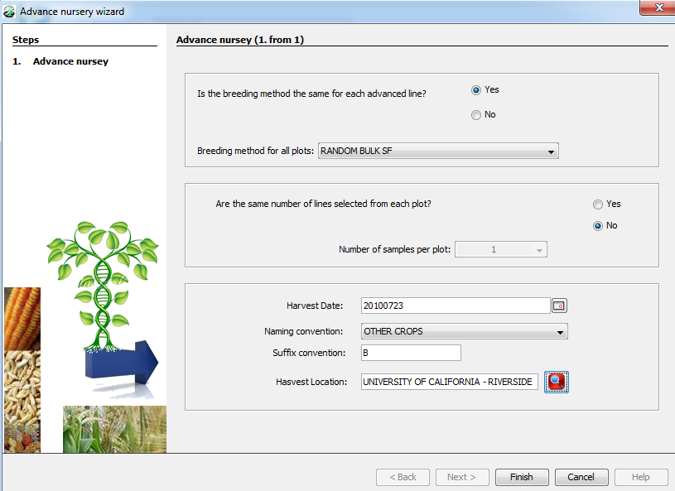

7. A list of candidate derived lines is presented. Enter a Nursery name and description and click Save. Exit the Breeding manager.

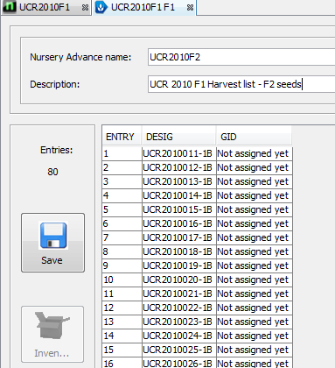

B. Make the F2 Nursery Book
Tutorial Steps:

- Run the Breeding Manager from the IB Workbench.

- Go to Study Explorer and highlight the study which is “UCR2010 Nurseries”. Create a new nursery by right clicking on Nurseries and click New Nursery.

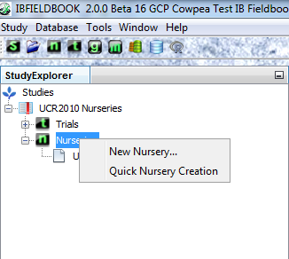

- The “Create New Nursery Wizard” will appear.

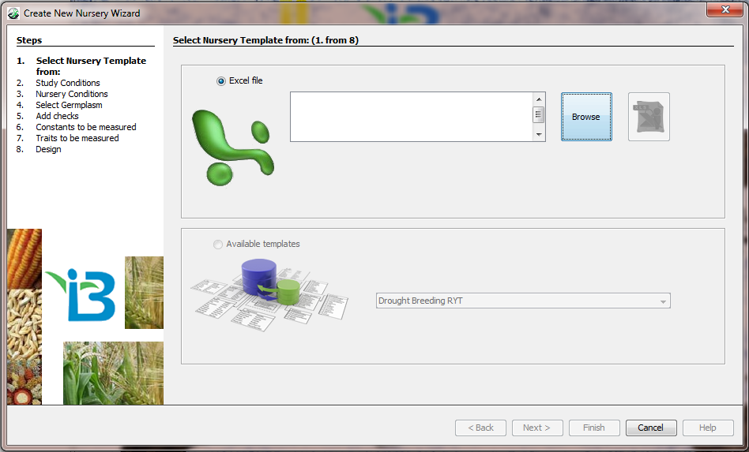

- Click the Browse button and navigate to your templates folder. For purposes of this tutorial, you can use a sample template found in the ICIS5\Documents\Templates\IVIS that is automatically created during installation of the program. Select “Cowpea – Nursery Template.xls” from the Templates folder and click ‘Open’.

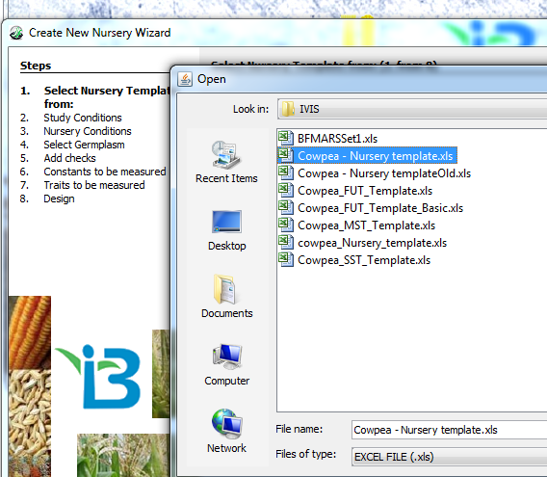

The template file name will appear in the box to the left of the browse button. Once the template file name appears you can view the selected template by clicking the Preview button found to the right of the Browse button.

Note: The nursery template specifies the sampling structure and it offers a list of traits for observation. Nursery templates have a special format and are created by researchers and data managers.

- Click Next. In the left hand column of the browser, Step No. 2 ‘Study Conditions’ will be in bold. The list of study conditions is specified by the nursery template. Enter the values for those conditions in the Value column by typing values or selecting from pick lists when available.

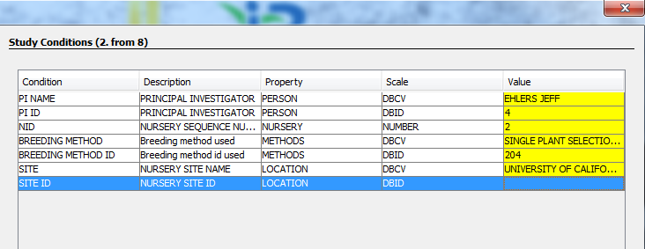

Note: Study conditions specify relevant conditions for the whole nursery – e.g. the breeding method used (as in the example shown).

- Click Next. The Germplasm selection page will appear. Step 4 ‘Select Germplasm’ will appear in bold in the left hand side.

Specify the nursery list from the database. Go to the last end of the list box and select “UCR2010F2”.

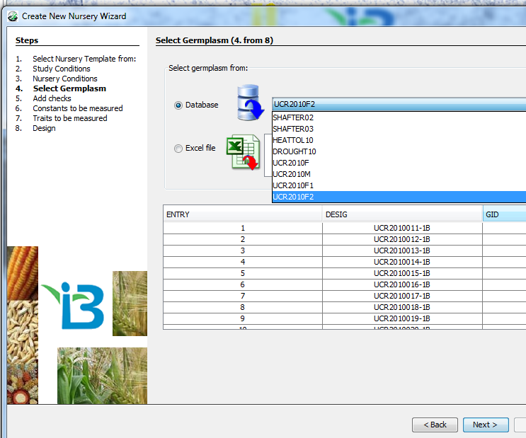

- Click Next. The Add Checks page will appear. “Step 5. Add Checks” will appear in bold on the left-hand side. We will not add checks to the F2 Nursery so click Next.

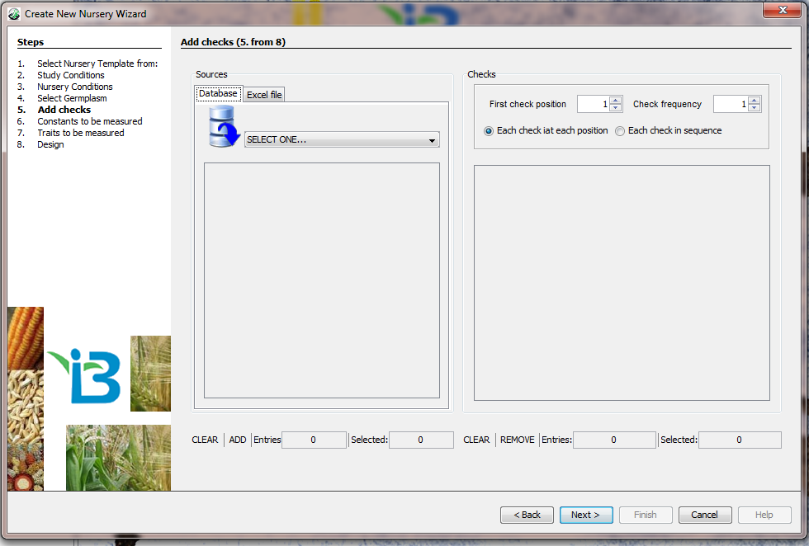

- The ‘Traits to be Measured” page will appear and ‘Step 7. Traits to be measured” will be in bold on the left-hand side.

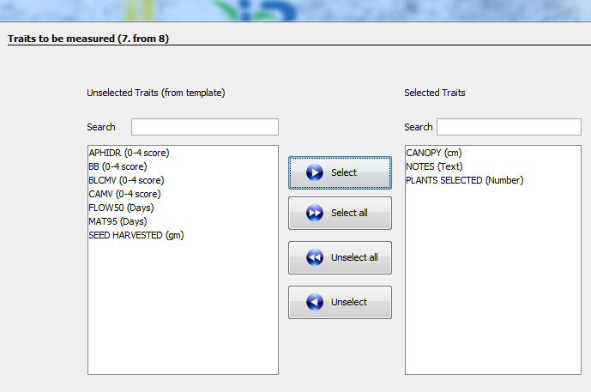

These will be automatically entered from the nursery template into the Unselected Traits field box. Individual trait to be observed for each trial instance can be selected by dragging desired trait from the Unselected Traits set into the Selected Traits set or – alternatively – selecting each and clicking the “Select” button. All can be selected by simply clicking the “Select All” button. Traits can be unselected in the same manner. Fields will be made available in the Fieldbook for the associated observations for each trait instance.

In this example, select CANOPY, NOTES and PLANTS SELECTED..

- Click Next. The ‘Design’ page will appear and ‘Step 8. Design” will be in bold on the left hand side.

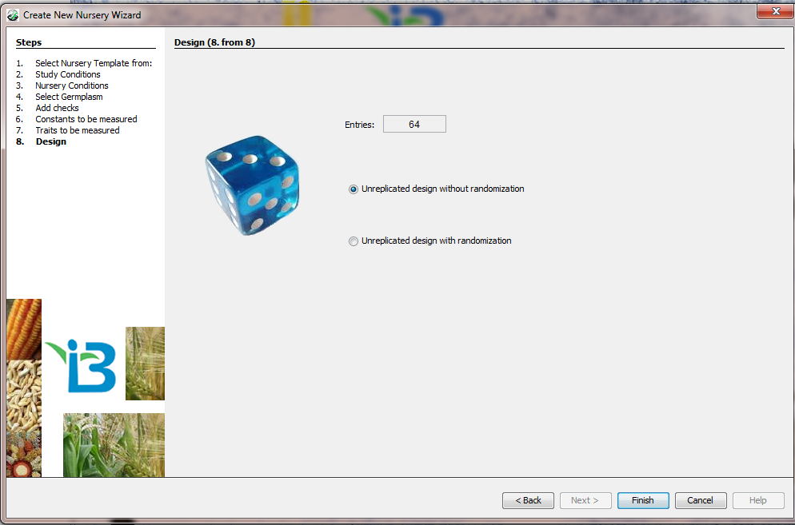

- In this example, tag the “Unreplicated design without randomization”

- Click Finish. The Trial Editor page will appear.

- Information from each step in the nursery wizard is contained on a separate tab of the Nursery Editor. The editor allows the user to view and edit all elements of the nursery book.

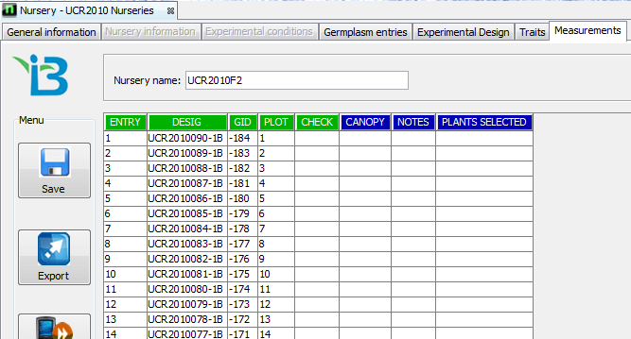

- Enter a name in the text box beside Nursery name. In this example, enter “UCR2010F2”. Then click the Save button on the left side. A message will appear that it has successfully saved the nursery. Click OK.

- To export the nursery book for data collection, press the Export button located on the left-hand side of the spread sheet.

- The Export Wizard will appear with the Destination page opening first. This page allows you to choose the destination to export the data that is shown in the measurements tab.

For this exercise, choose the third option, Excel file radio button. Click Next.

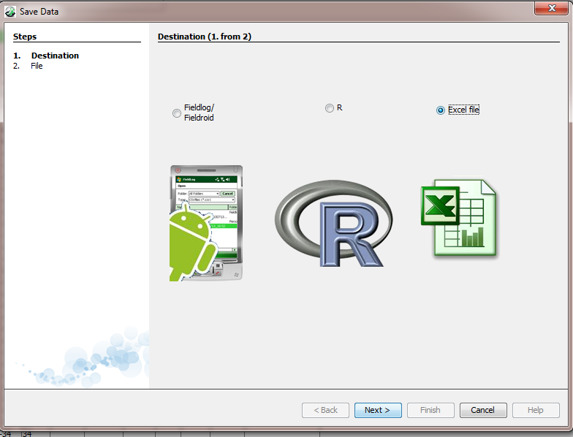

- Click Browse to go to the folder where to store the Excel file.

- Type the name of the file, “UCR2010F2.xls”, and click Save.
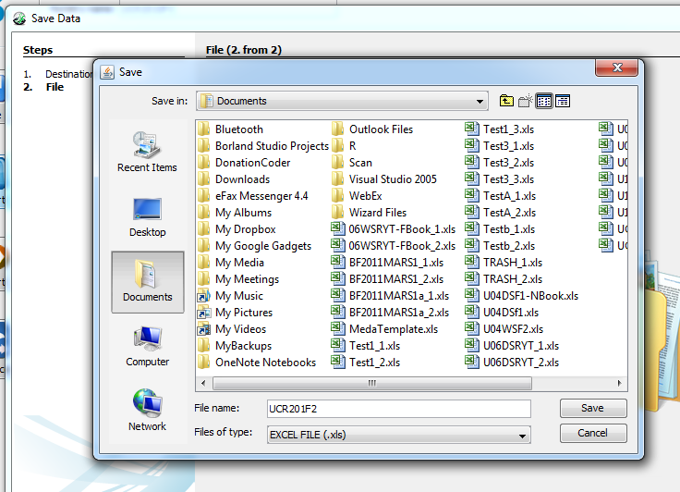

- A message box will appear asking if you want to open the file.

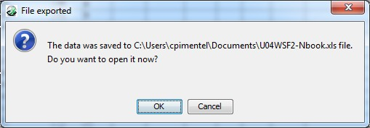

Click OK if you want to open it, otherwise click Cancel. In this example, click OK to see the nursery book.

- You can either print or transfer the F2 nursery book to a handheld device for data recording.

